KLE Technological University, Belagavi
Computer Science & Engineering (AI)
Agentic AI (26ECAC401) — Lab Worklet Review & Evaluation Sheet
14 Hands-on Labs · to be filled by the student team and marked by the reviewer
Team name / number | [TEAM NAME / NUMBER]
Worklet title | Curriculum Intelligence — AI-Assisted Academic Curriculum Design (Labs 1–8)
KPI & Expectations | [KPI & EXPECTATIONS]
Team members (Name — USN) | [TEAM MEMBERS / USNs]
Review (Week / date) | [REVIEW DATE]
How each lab is marked (max 10 per lab)
• Concept (2) — Is the lab’s concept correctly understood and clearly mapped to the team’s worklet?
• Technical stack (2) — Is the chosen stack appropriate and correctly justified for the task?
• Implementation (4) — Does the implementation work and correctly realise the concept (loop / tool / skill / graph / etc.)?
• Explanation & demo (2) — Is the explanation clear and supported by evidence — repo, screenshots, or a live demo?
Instructions: The team fills the four shaded description rows for every lab (be specific; attach evidence). The reviewer fills the marks strip and remarks. Total = sum of 14 labs (out of 140); scale to the lab component weightage as required.

Contents
1. Project Overview
2. System Architecture
3. Lab 1 — Agent vs Chatbot
4. Lab 2 — Tool-Using Agent
5. Lab 3 — Skill Creation
6. Lab 4 — Memory & Retrieval
7. Lab 5 — MCP-Style Connector
8. Lab 6 — OpenCLA / OpenClaw Runtime
9. Lab 7 — Agentic Node Graph
10. Lab 8 — Parallel Swarm
11. End-to-End Workflow
12. Testing & Validation
13. Demonstration Evidence
14. Current Limitations
15. Lab Completion Summary
16. Conclusion

1. Project Overview

1.1 What is Curriculum Intelligence?
Curriculum Intelligence is a professor-facing, AI-assisted system for designing a new academic course. Instead of starting from a blank page, the professor chooses the course to be created, and the system brings together reference curriculum information, what students have already studied, and the practical constraints of the department, and then proposes a structured course plan for the professor to review.

1.2 Problem addressed
Designing a new course normally requires comparing several university curricula, checking what students already know, fitting the result into credit and hour limits, and writing learning outcomes. This is slow and inconsistent when done by hand. Curriculum Intelligence automates the preparation work and keeps the final academic decision with the professor.

1.3 What the professor enters
- The course to be created (for example, Agentic AI).
- The courses students have already completed (for example, Machine Learning, Deep Learning, Natural Language Processing, Data Structures and Algorithms), with the option to add another course.
- Course constraints: available credits, target semester, teaching structure, laboratory requirement and any additional requirements.

1.4 What the system does and produces
The system reviews reference curriculum information (topics found across sources and a comparison of course structures), analyses the prerequisites implied by the student background, and generates a proposed course plan. The plan shows the course name, credits, structure, lecture hours, lab hours, modules, course structure, prerequisite analysis, learning outcomes, the evidence used, and the gaps identified.

1.5 Role of human approval
No recommendation is treated as final. The plan reaches a review page where human approval is required, and the professor can Approve, Edit or Reject it. Only after approval is the plan shown as approved and ready for publication.

1.6 Overall workflow
The professor-facing interface is a simple step-by-step wizard (Home → Create New Course → Course → Global Curriculum Research → Student Background → Course Constraints → Proposed Course Plan → Review / Approval). A separate “Labs & System” page exists only to demonstrate the underlying technical implementation of Labs 1–8; the wizard is the main product.
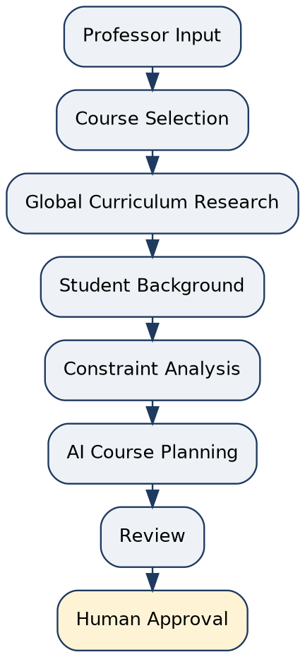
Figure 1: Overall professor-facing workflow
Data note. In the current demonstration mode, the university sources shown under Global Curriculum Research and the curriculum memory that is loaded into the application are MOCK / DEMONSTRATION DATA. They are illustrative and are not live or verified university data.

2. System Architecture
The system is organised in layers. The Streamlit interface collects the professor’s input and passes it to the Coordinator. The Coordinator uses tools, skills and memory, which obtain data only through a governed connector. A governed runtime controls execution, the agent graph carries out the multi-agent workflow, and the parallel swarm analyses curriculum sources. The result is a course recommendation that must pass human approval.
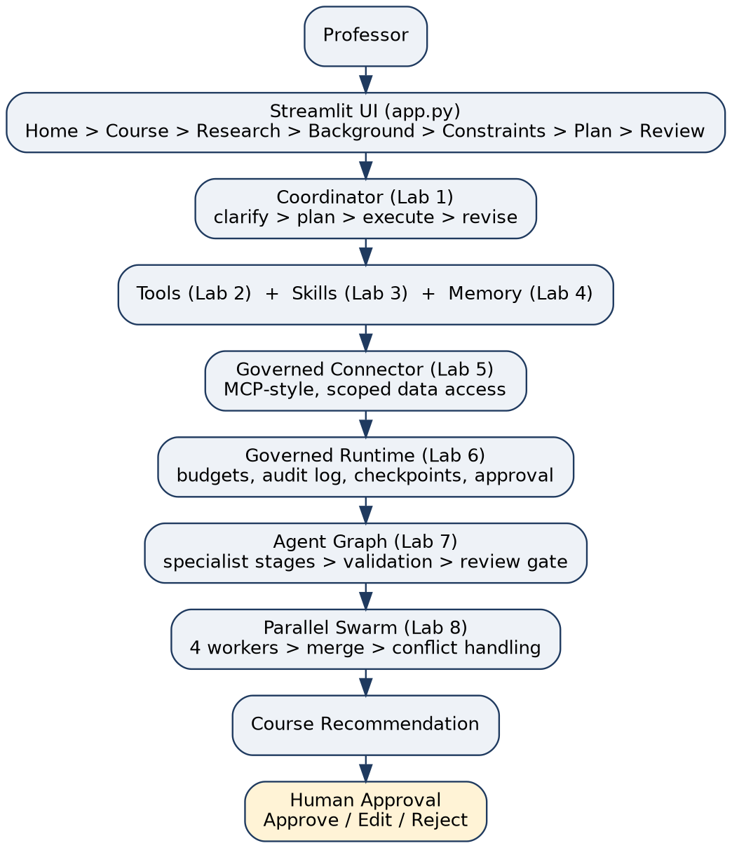
Figure 2: Layered architecture of Curriculum Intelligence
Layer | Location | Lab
Streamlit UI (professor-facing wizard) | app.py | —
Coordinator (agent loop) | src/coordinator.py | 1
Tools | src/tools/ | 2
Skills | src/skills/ | 3
Memory and retrieval | src/memory/ | 4
Governed connector | src/connector/ | 5
Governed runtime | src/runtime/ | 6
Agent graph | src/graph/ | 7
Parallel swarm | src/swarm/ | 8

LAB 1 — AGENT VS CHATBOT
Concept (professor’s sheet): Agent loop and the plan–act–observe–revise cycle (versus a stateless chatbot).

1. Concept Applied
A chatbot answers one message and stops. An agent works in a loop: it decides what is missing, plans, acts, looks at the result, and revises. In Curriculum Intelligence this concept is applied to the request “design a new course”, which is deliberately underspecified at the start (the professor may give only a course name). The loop used is:
clarify → plan → execute → revise
- Clarify: the coordinator identifies what is missing from the request (for example student background and constraints) instead of guessing.
- Plan: it prepares the steps needed to produce a course plan from the available inputs.
- Execute: it carries out the planned steps using the tools, skills and memory of the later labs.
- Revise: the outcome can be revised when the inputs or the review outcome change.
Where: src/coordinator.py, which is also the entry point of the overall architecture.

2. Technical Stack
Item | Used
Language | Python
Interface | Streamlit (wizard in app.py)
Implementation | Coordinator in src/coordinator.py
External services / models | None are claimed in this document

3. Implementation
The coordinator handles an underspecified curriculum request and supports clarification, planning, execution and revision. In the professor-facing wizard this is visible as the guided sequence: the system asks for the course, the student background and the constraints before it produces a plan, and the plan can be reviewed and revised rather than being a single fixed answer.
Why this is an agent loop and not a one-shot chatbot: the request is not answered in a single reply. The system first checks what information is missing, keeps the collected information across steps, acts on it in stages, and can revise its output afterwards. A one-shot chatbot would produce an answer immediately from the first message, without this cycle.

4. Evidence
Evidence | Reference
Implementation | src/coordinator.py (agent loop: clarify, plan, execute, revise)
Professor-facing behaviour | Wizard steps Course → Research → Student Background → Constraints → Proposed Course Plan → Review
Demonstration | Streamlit application (Labs & System page and main wizard)

[ ATTACH APPLICATION SCREENSHOT ]
Suggested: wizard showing the clarification inputs and the resulting proposed plan
No screenshot, sample output or test result is included here unless you attach it above.

LAB 2 — TOOL-USING AGENT
Concept (professor’s sheet): Tool integration and function calling.

1. Concept Applied
A tool-using agent does not rely only on its own text generation; it calls defined tools to obtain structured, reliable information. In Curriculum Intelligence, tools give the agent workflow controlled access to curriculum data, industry information and a coverage calculation, so that later planning steps work from structured results.
Where: src/tools/

2. Technical Stack
Item | Used
Language | Python
Tool package | src/tools/
Consumers | Coordinator, skills and graph agents
External services / models | None are claimed in this document

3. Implementation
Three tools are implemented:
Tool | Purpose
CurriculumReaderTool | Reads curriculum information (topics, structure of reference courses) so the workflow can compare sources.
IndustrySignalReaderTool | Reads industry-signal information (skills and topics that industry expects) for benchmarking.
CoverageCalculatorTool | Calculates how well a set of topics covers a target, supporting gap identification.

These tools give the agent workflow structured information, which the skills and graph stages then use to identify gaps and build the proposed course plan.

4. Evidence
Evidence | Reference
Tool implementations | src/tools/ — CurriculumReaderTool, IndustrySignalReaderTool, CoverageCalculatorTool
Tool output in the application | Evidence used and gaps identified on the Proposed Course Plan page
Demonstration | Streamlit Labs & System page

[ ATTACH APPLICATION SCREENSHOT ]
Suggested: Lab 2 tool demonstration, or the Proposed Course Plan showing evidence used and gaps

Not stated in the supplied implementation summary (therefore not claimed): tool input schemas, tool-chaining behaviour and tool-level error handling. Add these only if you can confirm them from the code.

LAB 3 — SKILL CREATION
Concept (professor’s sheet): Reusable skills (instructions + tools + resources).

1. Concept Applied
A skill packages a complete, reusable behaviour: instructions on how to do a job, the tools it uses, and the resources it needs. It is larger than a helper function because it represents a task the agent can perform for many different requests. In Curriculum Intelligence, planning a course and formatting curriculum output are packaged as skills.
Where: src/skills/

2. Technical Stack
Item | Used
Language | Python
Skill package | src/skills/
Supporting layers | Tools (Lab 2) and memory (Lab 4) where applicable
External services / models | None are claimed in this document

3. Implementation
Skill | Purpose
CoursePlanningSkill | Packages the curriculum-planning behaviour: turning curriculum evidence, student background and constraints into a structured course plan.
CurriculumFormattingSkill | Packages the presentation behaviour: putting curriculum content into a consistent, readable structure (modules, hours, outcomes).

Why these are skills, not just helper functions: each one combines a defined instruction set (what to do and in what form), reusable behaviour, and the supporting tools or resources it draws on, and each one is independent of one particular course. Planning or formatting for a different course only needs different inputs; the skill itself does not change.
Reuse example: the same CoursePlanningSkill can be used for a course other than Agentic AI by supplying a different course name, student background and constraints.

4. Evidence
Evidence | Reference
Skill implementations | src/skills/ — CoursePlanningSkill, CurriculumFormattingSkill
Skill output in the application | Proposed Course Plan page (course structure, modules, hours)
Demonstration | Streamlit Labs & System page

[ ATTACH APPLICATION SCREENSHOT ]
Suggested: Lab 3 skill demonstration, or the formatted Proposed Course Plan

LAB 4 — MEMORY & RETRIEVAL
Concept (professor’s sheet): Short-term state versus long-term retrieval (RAG).

1. Concept Applied
An agent needs two kinds of memory. Short-term memory holds the state of the current run, and long-term memory holds stored knowledge that can be retrieved when needed. Curriculum Intelligence implements both and keeps them separate.
Kind | Component | Role
A. Short-term / current run state | RunState | Holds the state of the current workflow run (the professor’s inputs and progress).
B. Long-term stored memory | MemoryStore | Holds stored curriculum information that persists beyond one run.
C. Retrieval | retrieval (src/memory/) | Retrieves stored curriculum information for use in the current workflow.

Where: src/memory/, connected to the professor-facing workflow through app.py.

2. Technical Stack
Item | Used
Language | Python
Memory package | src/memory/ (RunState, MemoryStore, retrieval)
Integration | app.py (Streamlit wizard)
Data | MOCK / DEMONSTRATION DATA seeded into the store

3. Implementation
RunState represents the short-term workflow state, MemoryStore represents longer-term stored information, and the retrieval component fetches stored curriculum information for the workflow. The memory functionality has been connected to the main Streamlit wizard through app.py, so the wizard’s research and evidence steps use retrieved curriculum information.
MOCK / DEMONSTRATION DATA: the application is seeded with demonstration curriculum memory. It is illustrative and must not be read as live or verified university data.
Simple memory flow:
Professor input → RunState (current run) | MemoryStore (stored curriculum) → retrieval → evidence used in the proposed plan

4. Evidence
Evidence | Reference
Implementation | src/memory/ — RunState, MemoryStore, retrieval
Integration | app.py connects MemoryStore, RunState and retrieval to the wizard
In the application | Evidence used section on the Proposed Course Plan (demonstration data)

[ ATTACH APPLICATION SCREENSHOT ]
Suggested: Proposed Course Plan showing evidence used (label: mock / demonstration data)

Not stated in the supplied implementation summary (therefore not claimed): tag filtering, similarity search, and stale or conflicting-memory handling.

LAB 5 — MCP-STYLE CONNECTOR
Concept (professor’s sheet): Model Context Protocol and connectors.

1. Concept Applied
A connector places a controlled boundary between agents and data. Instead of every agent opening files or databases directly, agents request data through one governed endpoint that decides what is allowed. The Model Context Protocol (MCP) popularised this idea for AI agents.
Important: this project implements an MCP-style governed connector. It follows the connector concept but is our own implementation; it is not claimed to be the official MCP protocol.
Where: src/connector/

2. Technical Stack
Item | Used
Language | Python
Connector package | src/connector/
Demonstration | Lab 5 interface in the Streamlit Labs & System page
Official MCP SDK / protocol | Not used / not claimed

3. Implementation
The governed connector is the controlled data-access boundary of the system. Agents obtain curriculum data through the connector rather than by directly opening files or databases. The implementation includes authorization and scope concepts, so a request is checked against what the requester is permitted to access before data is returned. This gives:
- Governed data access through a single controlled endpoint.
- Authorization and scope checks on requests.
- No direct, uncontrolled data access by agents.
The application demonstrates the connector through the Lab 5 interface.

4. Evidence
Evidence | Reference
Implementation | src/connector/ (governed connector with authorization / scope concepts)
Demonstration | Lab 5 interface in the Streamlit application

[ ATTACH APPLICATION SCREENSHOT ]
Suggested: Lab 5 connector interface

Not stated in the supplied implementation summary (therefore not claimed): a discovery mechanism, specific request/response schemas, or a documented rejection example.

LAB 6 — OpenCLA / OpenClaw Runtime
Concept (professor’s sheet): Agent runtime with logging.

1. Concept Applied
A runtime is the layer that actually runs an agent under rules: how many steps it may take, how many tool calls it may make, what is logged, where it can be resumed, and when a human must approve. In Curriculum Intelligence this is the governed execution layer.
Important: this is a custom governed runtime that demonstrates the runtime concepts of the lab. It is not claimed to be the official OpenClaw software.
Where: src/runtime/

2. Technical Stack
Item | Used
Language | Python
Runtime package | src/runtime/
Demonstration | Runtime demonstration in the Streamlit Labs & System page
Official OpenClaw software | Not used / not claimed

3. Implementation
The runtime provides controlled execution through the following features:
Feature | Meaning in this project
Execution budgets | Limits on how much a run may do.
Max Steps | Upper limit on the number of steps in a run (configurable in the interface).
Tool Call Limit | Upper limit on tool calls in a run (configurable in the interface).
Max Retries | Upper limit on retries (configurable in the interface).
Audit logging | A record of what the run did.
Checkpoints | Saved points in a run.
Approval | A human approval step before the run proceeds to its final action.
Controlled execution | The run operates only within the limits above.

In the Labs & System page, the professor or reviewer sets Max Steps, Tool Call Limit and Max Retries and starts the run with the “Start Demonstration Run” action.

4. Evidence
Evidence | Reference
Implementation | src/runtime/ (budgets, audit log, checkpoints, approval, controlled execution)
Demonstration | Streamlit Labs & System page: Max Steps, Tool Call Limit, Max Retries, “Start Demonstration Run”

[ ATTACH APPLICATION SCREENSHOT ]
Suggested: runtime demonstration after clicking Start Demonstration Run

No audit-log excerpt or run output is reproduced here because none was supplied; attach it from the demonstration.

LAB 7 — AGENTIC NODE GRAPH
Concept (professor’s sheet): Graph-based orchestration (LangGraph).

1. Concept Applied
Graph-based orchestration expresses a multi-agent workflow as nodes (agents or stages) connected by edges, with a shared state moving through them and the ability to branch or retry. In Curriculum Intelligence the whole course-recommendation workflow is modelled as such a graph.
Important: this is our own Agentic Node Graph following the LangGraph-style concept of nodes and transitions. The official LangGraph library is not claimed to be used.
Where: src/graph/ (agents in src/graph/agents.py)

2. Technical Stack
Item | Used
Language | Python
Graph package | src/graph/
Agents | src/graph/agents.py (including RecommendationAgent)
LangGraph library | Not claimed

3. Implementation
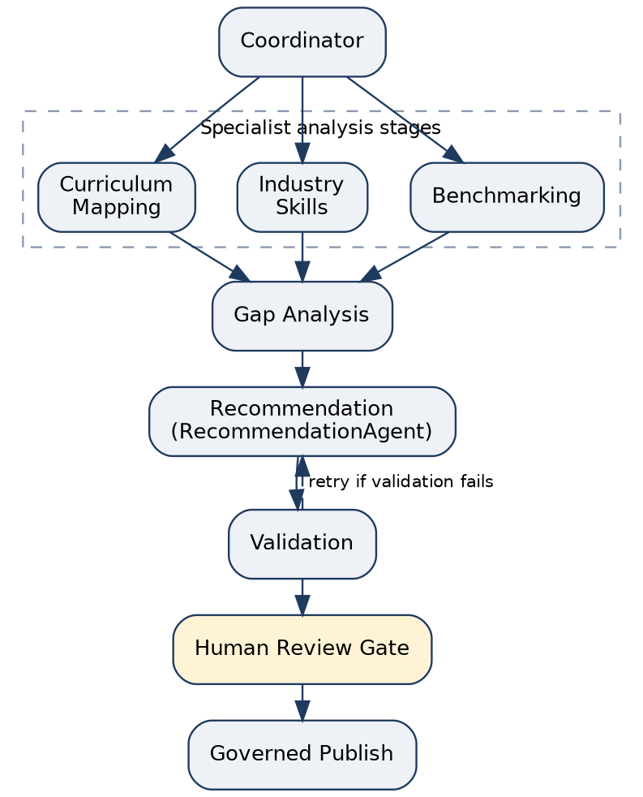
Figure 3: Agentic Node Graph of the course-recommendation workflow
Stage | Role
Coordinator | Starts the workflow from the professor’s request.
Curriculum Mapping | Specialist analysis stage: maps reference curricula.
Industry Skills | Specialist analysis stage: industry skill signals.
Benchmarking | Specialist analysis stage: benchmark comparison.
Gap Analysis | Identifies gaps between the evidence and the target course.
Recommendation | RecommendationAgent produces the proposed course.
Validation | Checks the recommendation; the graph includes validation/retry behaviour.
Human Review Gate | Human approval before the result can be published.
Governed Publish | Publishes only after approval.

Recent updates: the RecommendationAgent now includes learning outcomes in the proposed course. A helper, _derive_learning_outcomes(), derives them, and learning_outcomes is part of the proposed_course result. The total-hours formula was also corrected from (L+T+2P)×15 to (L+T+P)×15.

4. Evidence
Evidence | Reference
Implementation | src/graph/ — agent graph; src/graph/agents.py — RecommendationAgent, _derive_learning_outcomes()
In the application | Proposed Course Plan page shows learning outcomes, modules, hours, evidence and gaps; Review page shows the human gate
Demonstration | Agent graph interface in the Streamlit Labs & System page

[ ATTACH APPLICATION SCREENSHOT ]
Suggested: agent graph interface / Proposed Course Plan with learning outcomes

LAB 8 — PARALLEL SWARM
Concept (professor’s sheet): Parallel execution, swarms and fault-tolerant merge.

1. Concept Applied
A swarm runs several worker agents at the same time on independent parts of a problem (fan-out) and then combines their results (fan-in). In Curriculum Intelligence, four workers analyse curriculum sources in parallel, and a merge step combines their outputs and deals with disagreements between them.
Where: src/swarm/ (merge logic in src/swarm/merge.py)

2. Technical Stack
Item | Used
Language | Python
Parallelism | Thread pool (ThreadPool) with 4 parallel workers
Swarm package | src/swarm/ (merge in src/swarm/merge.py)
Demonstration | Parallel swarm interface in the Streamlit Labs & System page (shows “4 parallel workers” and “Fan-In / Merge Strategy”)

3. Implementation
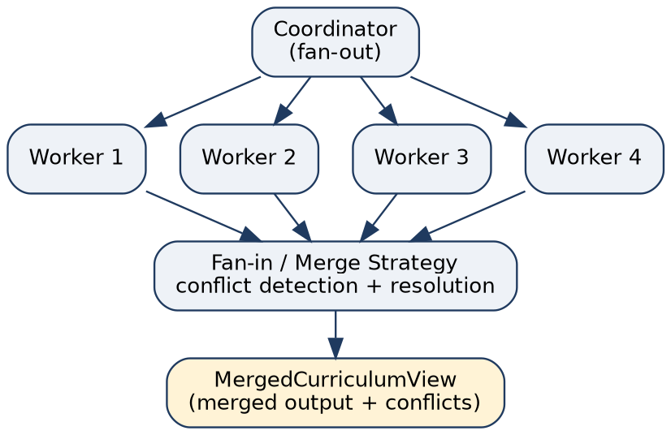
Figure 4: Fan-out / fan-in swarm with conflict-aware merge
- Fan-out: the coordinator gives independent curriculum sources to 4 parallel workers running in a thread pool.
- Independent analysis: each worker analyses its own source and returns its own output.
- Fan-in and merge: the worker outputs are combined into a MergedCurriculumView.
- Conflict detection: when sources disagree, the merge detects the conflict. Categories implemented: credits, structure and hours.
- Conflict resolution: detected conflicts are resolved by the merge layer and recorded in the conflicts field of MergedCurriculumView, so the disagreement remains visible.
Fault tolerance — what is and is not implemented. Conflict detection and resolution between worker outputs are implemented. Complete worker-failure fault tolerance (for example, continuing the merge after a worker crashes) is not claimed, because it is not part of the supplied implementation summary.
No timing comparison between sequential and parallel execution is reported, because none was measured for this document.

4. Evidence
Evidence | Reference
Implementation | src/swarm/ — parallel workers, worker outputs, merge
Merge / conflicts | src/swarm/merge.py — MergedCurriculumView with conflicts field (credits, structure, hours)
Demonstration | Parallel swarm interface: “4 parallel workers”, ThreadPool, “Fan-In / Merge Strategy”

[ ATTACH APPLICATION SCREENSHOT ]
Suggested: parallel swarm interface showing workers and merge strategy

11. End-to-End Workflow
Labs 1–8 are not separate exercises; they are layers of one system.
Lab | Contribution to the system
Lab 1 | Agent loop (clarify, plan, execute, revise)
Lab 2 | Tools for structured information
Lab 3 | Reusable skills
Lab 4 | Memory (short-term and long-term) and retrieval
Lab 5 | Governed data access
Lab 6 | Runtime control (limits, audit, checkpoints, approval)
Lab 7 | Agent graph orchestration
Lab 8 | Parallel analysis and merge

Putting it together, one run proceeds as follows:
- The professor enters the course.
- The system researches reference curriculum information (demonstration data in this prototype).
- The student background is considered.
- AI generates a course structure.
- The agent graph validates the recommendation.
- Parallel workers provide curriculum analysis.
- The results are merged, with conflicts detected and resolved.
- A human reviews the plan.
- The professor approves, edits or rejects it.

12. Testing & Validation
Implementation was developed and demonstrated through the project’s lab interfaces and implementation components. Exact automated test counts are not included in this documentation because this document is based on the current implementation summary.
No automated test results, timings or benchmark figures are reported here. The evidence for each lab is the implementation location and its demonstration in the Streamlit application, listed in Section 13.

13. Demonstration Evidence
Screenshots must be captured from the running application and attached in the last column; none are included in this document.
Lab | Evidence | Screenshot to attach
Lab 1 | src/coordinator.py + agent workflow | Attach application screenshot
Lab 2 | src/tools/ + tool demonstrations | Attach application screenshot
Lab 3 | src/skills/ + skill demonstrations | Attach application screenshot
Lab 4 | src/memory/ + Streamlit memory integration | Attach application screenshot
Lab 5 | src/connector/ + connector interface | Attach application screenshot
Lab 6 | src/runtime/ + runtime demonstration | Attach application screenshot
Lab 7 | src/graph/ + agent graph interface | Attach application screenshot
Lab 8 | src/swarm/ + parallel swarm interface | Attach application screenshot

14. Current Limitations
- Global curriculum research shown in the current demonstration interface uses mock / illustrative data.
- The system is a demonstration / prototype and requires real research-enabled data sources for production deployment.
- Human academic approval is required before final publication.
- Exact automated test statistics are not claimed in this document.
- Official MCP, LangGraph and OpenClaw terminology is used only where the implementation supports it: the connector is MCP-style, the graph is a custom Agentic Node Graph, and the runtime is a custom governed runtime.
- Lab 8 implements conflict detection and resolution; complete worker-failure fault tolerance is not claimed, and no parallel timing measurements are reported.
- Labs 9–14 are outside the scope of this document and are not claimed as completed.

15. Lab Completion Summary
Lab | Status | Main Implementation
Lab 1 | Implemented | Agent loop / coordinator
Lab 2 | Implemented | Tool system
Lab 3 | Implemented | Reusable skills
Lab 4 | Implemented | Memory + retrieval
Lab 5 | Implemented | MCP-style governed connector
Lab 6 | Implemented | Governed runtime
Lab 7 | Implemented | Agent graph
Lab 8 | Implemented | Parallel swarm + merge / conflict handling

Marks are to be assigned by the reviewer on the official evaluation sheet.

16. Conclusion
Curriculum Intelligence brings the first eight Agentic AI concepts together in one academic curriculum-design system: an agent loop, tools, reusable skills, memory and retrieval, a governed connector, a governed runtime, an agent graph and a parallel swarm. The professor stays in control: the system prepares and validates a recommendation, and a human approves, edits or rejects it before publication.

